Kondrashov’s [, 1985 #5375] model of genomic mutation

Douglas G. Scofield
Department of Biology
University of Miami

March 8, 2003

ABSTRACT
Kondrashov [, 1985 #5375] introduced a new form of iterative model for the study of the effects of genomic mutation that many authors have found useful [e.g., \Charlesworth, 1990 #5337; Lande, 1994 #5345; Schultz, 1995 #541; Muirhead, 1997 #5426; Morgan, 2001 #5443]. The model was novel in that it never modeled loci directly. Rather, it considered the expected proportion, in an infinite population, of genotypic classes carrying i heterozygous mutations and j homozygous mutations if genomes consisted of infinite completely independent loci with perfect Mendelian segregation. Mutations are never identical via descent, and thus homozygous, except through selfing. The model can be tricky to implement, especially in terms of efficient computation. Here I describe Kondrashov’s original formulation, a useful variant by Charlesworth et al. [, 1990 #5337], and summarize other selected variants. I address implementation issues and suggest a potential approach to increase the speed of convergence to equilibrium. Finally, I provide C source code for the model and several variants.

Kondrashov’s original model
Mutation. Equation (2) on p. 638 of Kondrashov [, 1985 #5375] defines the mutation process.
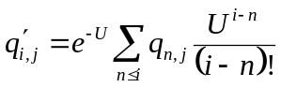 (K1.1)
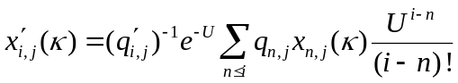 (K1.2)
New mutations are assumed to be unique and thus only affect homozygous wild-type loci, thus each new mutation is a new heterozygous mutation. The number of new mutations follows a Poisson distribution with mean U. After mutation, load class proportions are shifted towards higher i resulting in greater average population heterozygous load. A portion of each load class q_{n,j} is added to the post-mutation load class q’_{i,j} (where i  n) equivalent to the (i – n)^{th} term of the Poisson distribution: 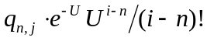. From equation (K1.1), post-mutation load classes contain the contributions of all load classes where i  n.

Introduction
Kondrashov [, 1985 #5375] introduced a new form of model which he used to study the effects of mating system (facultative selfing or apomixis) on population genetic load with recurrent deleterious mutation to mutant alleles having a fixed dominance and selective effect. The model is novel in that it does not explicitly consider genomes or mutations. The population is represented by proportional membership in genomic classes G_{i,j} where i ∈ [0, M_{i}], j ∈ [0, M_{j}] and 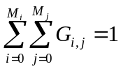. Each G_{i,j} may be further subdivided into proportions of up to κ genotypes so that G_{i,j}(ξ) is the portion of G_{i,j} having the ξ ^{th} genotype such that 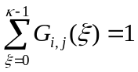. The population proportion of G_{i,j} that is the ξ ^{th} genotype is thus 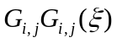 and 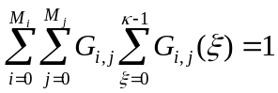.
Values of M_{i} and M_{j}. The values of M_{i} and M_{j} are chosen based upon classical expectations for frequencies of heterozygous and homozygous deleterious alleles under selection, such that membership in classes where i > M_{i} or j > M_{j} is not possible. For example, values of M_{i} must be greater if mutations have both low dominance and low selective effect, while values of M_{j} may be very low for highly recessive lethal mutations. Due to selection, there is no strict requirement that M_{j} = M_{i} as would be expected for neutral mutations. I know of one implementation where M_{i} = 200 and M_{j} = 40. Neither Kondrashov [, 1985 #5375] nor Charlesworth et al. [, 1990 #5337] explicitly note the need to determine M_{i} and M_{j}.
Effects of mutations. Mutations occur at rate U per diploid genome per generation and independent mutations are never identical, thus new mutation only increases i, never j. Another consequence of independence of loci occurs during production of zygotes. When an outcrossed zygote is produced from the union of two haploid gametes carrying m and n mutations, respectively, the new outcrossed zygote carries m+n heterozygous mutations and 0 homozygous mutations. Zygotes can only contain loci homozygous for mutations if they are produced through selfing, the union of gametes produced by the same individual. Homozygous mutant loci occur in selfed zygotes at the Mendelian rate of 0.25 per heterozygous locus. Identity by descent other than that occurring via selfing within a single generation is not possible. Thus this model cannot be used for finite or non-panmictic populations.
An analysis that does not consider selfing (that is, that examines outcrossing and/or apomixis) will never encounter homozygous mutations. Kondrashov [, 1985 #5375] provides representative formulae. Here I will assume the need to keep track of both allelic states.
The model cannot be solved analytically [Kondrashov, 1985 #5375]. Instead, the model is specified in a computer program and allowed to iterate until convergence to equilibrium is determined numerically. Equilibrium may be obtained within 50 to a few hundred generations, depending upon initial conditions [Charlesworth, 1990 #5337].
The sequence of steps performed, with the notation to be used here for the class proportions resulting from each step, is:
1. reproductive adults (q_{i,j}) →
2. mutation (q′_{i,j}) →
3. fusion to selfed zygotes (q′′_{(s)i,j}) →
4. production of haploid gametes (male f_{i} and female g_{i}) →
5. fusion to outcrossed zygotes (q′′_{(x)i,j}) →
6. selection (Q_{i,j}) →
7. next generation of reproductive adults (q_{i,j} ≡ Q_{i,j}) ↑
Note that in the discussion that follows, the notation G_{i,j} indicates a general statement about the genotype class containing i heterozygous mutations and j homozygous mutations, while the notation, e.g., q_{i,j} and q′′_{(x)i,j} indicate a specific statement about the G_{i,j} class proportions resulting from the specific model step indicated by the notation.
Model execution times may be long because of the need for repeated matrix operations to determine membership in each G_{i,j} resulting from each step. Convergence analysis as a shortcut to equilibrium might be possible, but has not yet been attempted (M. Morgan, personal communication). Execution time and space requirements are at least O(M_{i}² × M_{j}²), thus it is critical not to choose M_{i} and M_{j} that are unnecessarily large. Later in this paper I will (a) sketch a possible approach to convergence analysis and (b) present some rules of thumb for choosing M_{i} and M_{j}.

Model sequence

Step 1: Reproductively mature hermaphroditic adults (q_{i,j})
Kondrashov apparently initiates the model with mutation-free adults:
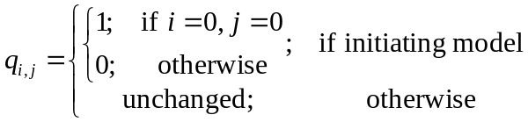 (*INIT*)
Charlesworth et al. initiate the model with “low numbers of mutations” [, 1990 #5337:1473], perhaps by applying equation (*MUT*) one or more times immediately following equation (*INIT*). If the model has already undergone one iteration, then the q_{i,j} pass unchanged to the next step.

Step 2: New mutation in adults (q′_{i,j})
Mutation increases the proportion of individuals in class q′_{i,j} by adding mutated individuals from all classes q_{n1,j}, where i > n₁ and j remains constant. The number of new mutations follow a Poisson distribution with mean and variance U:
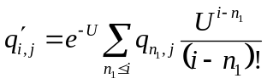 (*MUT*)
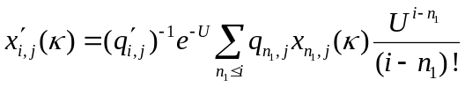 (*XMUT*)
Kondrashov defined several convenience variables for tracking resource usage in the population:
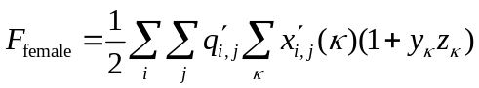 (*FFEMALE*)
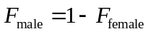 (*FMALE*)
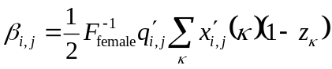 (*BETA*)
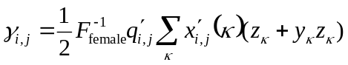 (*GAMMA*)
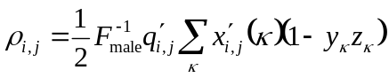 (*RHO*)
(*GK*)
(*AK*)
(*HK*)

Step 3: Production of selfed zygotes (q′′_{(s)i,j})
The proportion of new selfed zygotes belonging to class q′′_{(s)i,j} depends upon the selfing rate S, which represents the fraction of all ovules that are self-fertilized and is for the moment constant for all genotypes, and the proportion of G_{i,j} zygotes produced by selfing of each class q′_{i,j}. Kondrashov defines s_{i,j}(n₁,n₂) as the proportion of class G_{i,j} individuals produced by selfing of class G_{n1,n2} individuals:
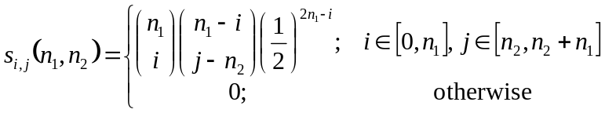 (*KSELFS*)
Thus the proportions of selfed zygotes in each class are:
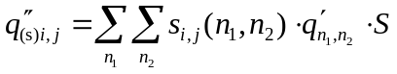 (*TOTSELFS*)

Step 4: Production of haploid gametes (f_{i} and g_{i}) by Charlesworth et al.
Charlesworth et al. calculate genotypes of the male and female gamete pools explicitly. The proportion of the haploid gamete class carrying i mutations is designated f_{i} (male) and g_{i} (female):
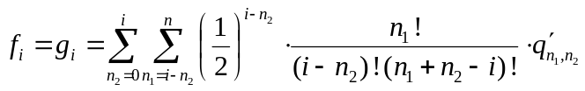 (*CHARGAM*)
Charlesworth et al. also describe modifications that allow for different selfing rates for different maternal genotypes. These modifications will be describe later in this paper.

Step 5: Production of outcrossed zygotes (q′′_{(x)i,j})
As described previously, the production of outcrossed zygotes is based upon the assumption of independent mutation. Thus, homozygous mutants are not produced through outcrossing (therefore outcrossed zygotes belong only to classes where j = 0) and the number of heterozygous mutant loci in an outcrossed zygote is the sum of the mutant loci in the gametes.
Kondrashov does not explicitly model the production of gametes, instead the outcrossed zygotes are produced directly. The contribution to class G_{i,j} of an outcrossed mating between an individual in class G_{n,v} and an individual in class G_{l,λ} is:
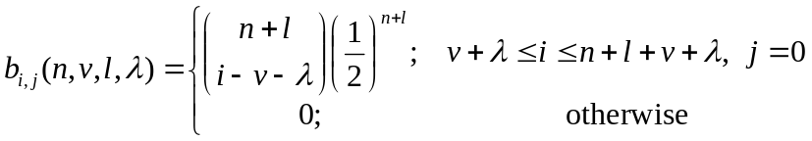 (*KB*)
The total contribution to outcrossed zygotes in each class is thus:
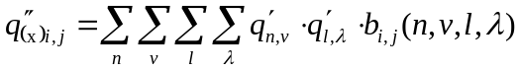 (*KONDOUTS*)
Charlesworth et al. designated the frequencies of outcrossed zygotes q′′_{(x)i,j} to be produced by fusion of gamete genotype classes f_{i} and g_{i}. There are two ways to produce an individual of class G_{i,0}: (1) the fusion of f_{k} and g_{i–k} gametes, where k ∈ [0, i] and thus k + (i – k) = i; or (2) the fusion of f_{i–k} and g_{k} gametes:
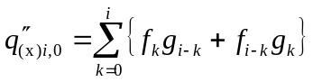 (*CHAROUTS*)

Step 6: Selection (Q_{i,j})
The zygote classes are pooled:
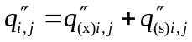
Selection is then imposed on q′′_{i,j} through reduction and/or increase in the proportional membership in each class, according to a fitness function w_{i,j} defined in terms of i and j. Kondrashov’s fitness function for selfing populations was
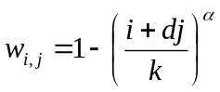 (*KONDFIT*)
where d expresses dominance, with d = 2 is additive dominance, and where α = 1, 2, and ∞ correspond to linear, intermediate and threshold selection respectively [Kondrashov, 1982 #6445]. With large d homozygous mutations are lethal. Individuals carrying k or more mutations died (as an aside, k may have been Kondrashov’s choice for M_{i} and M_{j}).
Charlesworth et al. [, 1990 #5337] employed a multiplicative fitness model with an s, h parameterization:
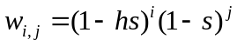 (*CHARFIT*)
Here s is the selection coefficient of the allele and h its dominance, giving fitness of a heterozygous mutant (1 – hs) and of a homozygous mutant (1 – s).
The application of the fitness function may differ between Kondrashov and Charlesworth et al. Kondrashov first computes mean population fitness:
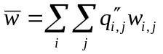 (*MEANFIT*)
and then determines Q_{i,j} with:
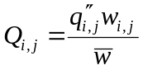 (*KONDSEL*)
Charlesworth et al. are less explicit. They appear to adjust class frequencies using just the numerator of equation (*KONDSEL*):
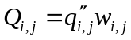 (*CHARSEL*)

Step 7: Renewal of reproductive adult population (new q_{i,j})
The class frequencies following selection Q_{i,j} and prior to the next generation must sum to one, a consequence of the probabilistic method used. The need to normalize is explicitly stated by Charlesworth but not by Kondrashov. Kondrashov’s use of 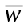 while applying selection may normalize the results but I’m not yet 100% certain. Normalization is required if the sum of all class frequencies is not one. The sum is computed and used to divide the frequencies of all classes prior to initialization of the next generation’s reproductive adult class frequencies:
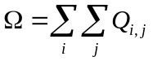 (*SUMFREQS*)
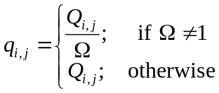 (*NORMEDNEXTGEN*)
and then the model continues with Step 1.

Determining convergence
Convergence is reached when class proportions do not change between generations.

An implementation in C
A reference implementation of the model is discussed. Code is included below and is also available online at http://fig.cox.miami.edu/~scofield/kondrashov. Though written in C, the design borrows techniques from object-oriented languages by separating the data structures used from specific procedures which manipulate them. The user defines the required arrays using the KArray and KVector datatypes and then calls the model procedures using the arrays as arguments. In this way, the model implementation need not be aware of other details concerning the actual storage locations of the arrays and any “wrapper” code being used.

